11 ATAR Chemistry

***Lab: Pigment Chromatography***

**Validation Name:_______________________**

View the chromatogram shown below. This was obtained after fresh leaves were ground in a mortar and pestle with sand and acetone, and the resulting pigmented liquid was dropped onto cellulose paper and suspending the paper in a solvent. After 30 minutes, the paper was removed from the solvent and the solvent origin and front marked using a pencil.

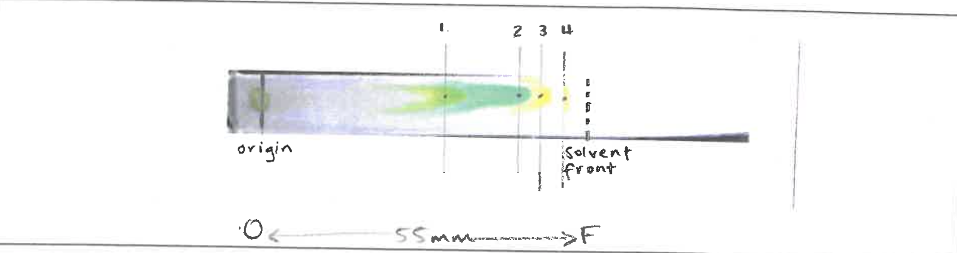

1. Measure the distance (in mm) travelled by the solvent. Measure the distance (in mm) that each pigment travelled from the point of application to its highest point on the paper. Calculate the Rf value for each pigment. Record the data in an appropriate table. (10 marks)

______________________________________________________________________________________________________________________________________________________________________

___________________________________________________________________________________

___________________________________________________________________________________

___________________________________________________________________________________

___________________________________________________________________________________

___________________________________________________________________________________

___________________________________________________________________________________

___________________________________________________________________________________

___________________________________________________________________________________

___________________________________________________________________________________

___________________________________________________________________________________

___________________________________________________________________________________

___________________________________________________________________________________

___________________________________________________________________________________

___________________________________________________________________________________

Reference values for plant pigments are give in the table below.

|  |  |  |
| --- | --- | --- |
| Pigment | Rf value range | Colour |
| Carotene | 0.89-0.98 | Yellow-Orange |
| Pheophytin a | 0.42-0.49 | Grey |
| Pheophytin b | 0.33-0.40 | Brown |
| Chlorophyll a | 0.24-0.30 | Lime green |
| Chlorophyll b | 0.20-0.26 | Olive (drab)Green |
| Xanthophylls | 0.04-0.28 | Yellow |

Use these values to identify the pigments present in the chromatogram above. (2 marks)

___________________________________________________________________________________

___________________________________________________________________________________

___________________________________________________________________________________

___________________________________________________________________________________

Why are the Rf values in the reference table given as a range? (2 marks)

___________________________________________________________________________________

___________________________________________________________________________________

___________________________________________________________________________________

___________________________________________________________________________________

What does a small Rf value indicate about the characteristics of moving molecules?

(2 marks)

___________________________________________________________________________________

___________________________________________________________________________________

___________________________________________________________________________________

___________________________________________________________________________________

Is it possible to have an Rf value greater than 1? Why or why not? (2 marks)

___________________________________________________________________________________

___________________________________________________________________________________

___________________________________________________________________________________

___________________________________________________________________________________

The Thin Layer Chromatograms of plant extracts shown below were obtained using two different solvents in the mobile phase. Both used silica as the stationary phase.

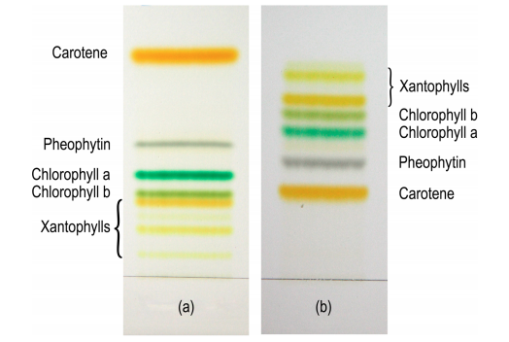

The scientist who produced these chromatograms stated:

*“In chromatogram A, carotene is the least polar compound.”*

What evidence is there (in Chromatogram A) to show the relative polarity of carotene compared to the other pigments eluted? (2 marks)

___________________________________________________________________________________

___________________________________________________________________________________

___________________________________________________________________________________

___________________________________________________________________________________

Comment on the nature of the solvent used in the TL Chromatogram B. (2 marks)

___________________________________________________________________________________

___________________________________________________________________________________

___________________________________________________________________________________

___________________________________________________________________________________

How does the solvent in TL Chromatogram B differ? Explain your answer. (2 marks)

___________________________________________________________________________________

___________________________________________________________________________________

___________________________________________________________________________________

___________________________________________________________________________________

Your advisor tells you that he wants you to use HPLC to analyse the plant pigments.

Summarise the process of HPLC and explain why it may be advantageous to use over TLC (the use of a diagram is encouraged). (6 marks)

___________________________________________________________________________________

___________________________________________________________________________________

___________________________________________________________________________________

___________________________________________________________________________________

___________________________________________________________________________________

___________________________________________________________________________________

___________________________________________________________________________________

___________________________________________________________________________________

___________________________________________________________________________________

___________________________________________________________________________________

___________________________________________________________________________________

___________________________________________________________________________________

___________________________________________________________________________________

___________________________________________________________________________________

___________________________________________________________________________________

___________________________________________________________________________________